1. R Project-Prepare a dataset related to your own project and perform k-Means, k-Medians, Expectation Maximization (EM), Hierarchical Clustering and report the results.

**Description:**

K means:

Here we used the k means algorithm on the iris dataset as the data set collected by us dint have the variety of data for clustering yet. So we could collect all the algorithms required for our project and experiment it on the iris data set. K means uses the mean values to locate the centroids and clusters or groups the rest of the data set accordingly.

> iris3 <- iris

> iris2$Species <- NULL

> (kmeans.result <- kmeans(iris2, 3))

> plot(iris2[c("Petal.Length", "Petal.Width")], col = kmeans.result$cluster)

> points(kmeans.result$centers[,c("Petal.Length", "Petall.Width")], col = 1:3, + pch = 8, cex=2)

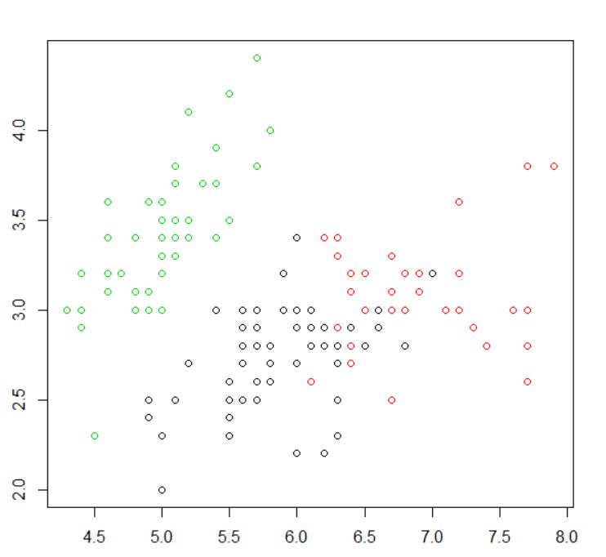

Kmedians:

The K medians is similar to k means however the k medians considers the median value for each group of data. By taking the median value we could eliminate the outliers which can affect the prediction.

> library(fpc)

> pamk.result <- pamk(iris2)

> # number of clusters

> pamk.result$nc

> # check clustering against actual species

> table(pamk.result$pamobject$clustering, iris$Species)

> layout(matrix(c(1,2),1,2)) # 2 graphs per page

> plot(pamk.result$pamobject)

> layout(matrix(1))

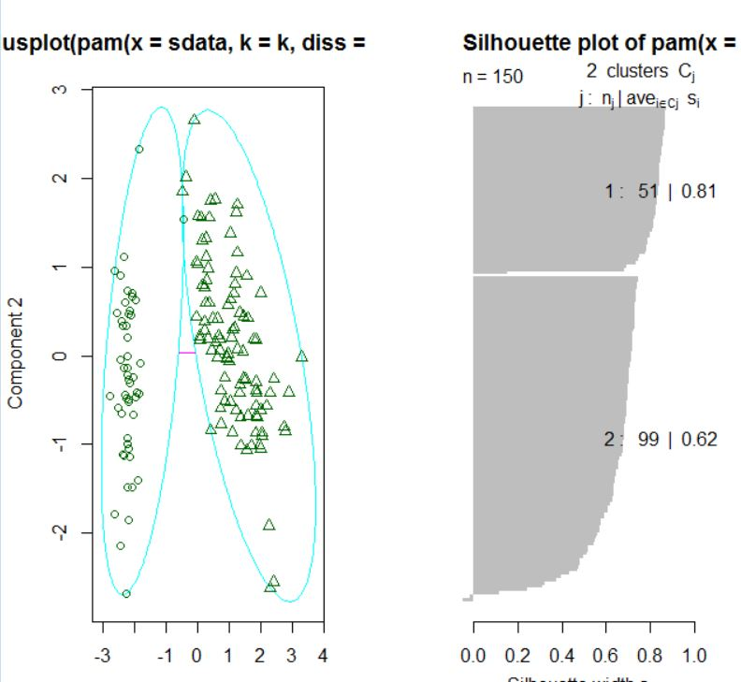

Hierarchical l Clustering: In Hierarchical clustering we generally use a greedy approach where the nodes in the clusters picks a nearest nodes to itself based on the similarities.

> layout(matrix(c(1,2),1,2))

> plot(pamk.result$pamobject)

> q()

> idx <- sample(1:dim(iris)[1], 40)

> irisSample <- iris[idx,]

> irisSample$Species <- NULL

> hc <- hclust(dist(irisSample), method="ave")

> plot(hc, hang = -1, labels=iris$Species[idx]

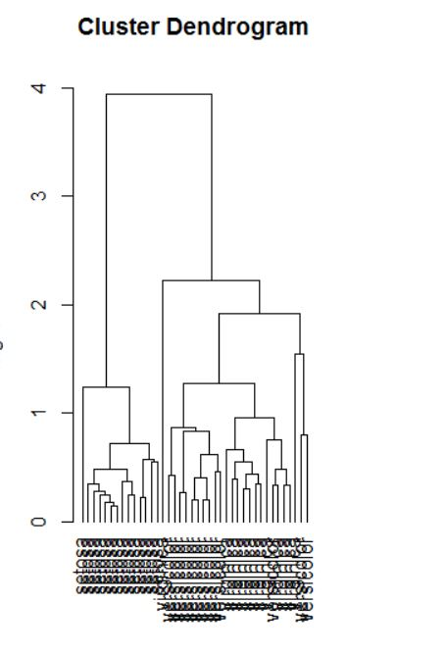

Expectation Maximization:

Expectation Maximization

-----------------------------------------------

library(mclust) # load mclust library

x1 = runif(20) # generate 20 random random numbers for x axis (1st class)

y1 = runif(20) # generate 20 random random numbers for y axis (1st class)

x2 = runif(20) # generate 20 random random numbers for x axis (2nd class)

y2 = runif(20) # generate 20 random random numbers for y axis (2nd class)

rx = range(x1,x2) # get the axis x range

ry = range(y1,y2) # get the axis y range

plot(x1, y1, xlim=rx, ylim=ry) # plot the first class points

points(x2, y2 ) # plot the second class points

mix = matrix(nrow=40, ncol=2) # create a dataframe matrix

mix[,1] = c(x1, x2) # insert first class points into the matrix

mix[,2] = c(y1, y2) # insert second class points into the matrix

mixclust = Mclust(mix) # initialize EM with hierarchical clustering, execute BIC and EM

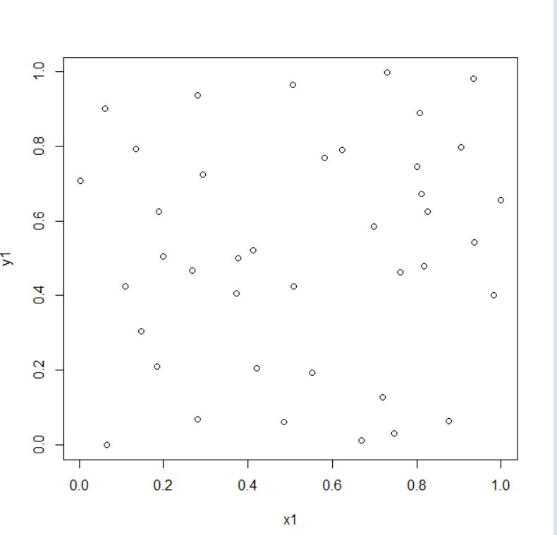

1. Watch Application-Data collection related to your own project through Smart Phone and Watch, send notifications to watch using intuitive data analysis.

**Description:**

In our project we basically check the health of the people hence Heartbeat is one of the important aspect. Hence with this smartwatch sensors I am trying to sense the heart beat and send the info to the smartwatch.

**Screenshots:**

